  - FLY GEAR SWAP / WORKSHOP GUIDE

Improving GPS acquisition in Betaflight 2026.6
  - Receiver setup and CLI reference
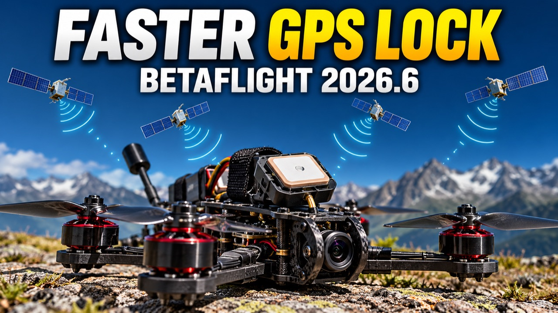
Illustration generated for this guide. October 1, 2026.
Improve GPS acquisition by starting with reception, verifying receiver compatibility, and testing one setting at a time. This guide explains the reference CLI settings for Betaflight 2026.6 and provides a measured approach to evaluating faster GPS lock.
Scope: Betaflight 2026.6, with firmware defaults checked against 2026.6.2. The u-blox settings below are intended for compatible receivers using the UBLOX provider. They are not a universal configuration for NMEA or DroneCAN GPS units. Hardware testing is still required.

Start with reception
Give the antenna a clear view of the sky and mount the receiver away from interference sources. Confirm the correct GPS UART, provider, wiring, and power supply. Some flight controllers do not power the GPS from USB. Auto-configuration needs communication from the flight controller to the receiver as well as GPS data coming back. Consult the board and module pinouts. Betaflight GPS setup

Back up and check your firmware
Remove the propellers before bench setup. Open the CLI in the Betaflight App and run these commands separately:
version
diff all
get gps
Save the output locally. Check that the firmware is 2026.6.x and inspect the GPS settings available in your actual build before changing anything.

The reference CLI settings
The following block reproduces the reference settings. Read the explanations below before applying changes; the two PORTABLE settings are not the stock 2026.6.2 models.
set gps_auto_config = ON
set gps_auto_baud = ON
set gps_update_rate_hz = 10
set gps_sbas_mode = AUTO
set gps_ublox_use_galileo = ON
set gps_ublox_acquire_model = PORTABLE
set gps_ublox_flight_model = PORTABLE
set gps_ublox_enable_ana = ON
Auto-configuration lets Betaflight configure a compatible receiver. The update rate controls how frequently it reports navigation data; 10 Hz does not mean it acquires satellites ten times faster. SBAS provides regional augmentation, and its availability depends on location and receiver support. PORTABLE is a low-acceleration model, so it should not be treated as an automatic improvement for an acrobatic quad. GPS configuration and dynamic models
The 2026.6.2 defaults are auto-configuration ON, auto-baud OFF, 10 Hz, SBAS NONE, Galileo OFF, acquisition model STATIONARY, flight model AIRBORNE_4G, and AssistNow Autonomous OFF. The reference block changes six of those defaults. Keep your existing working baud and dynamic-model settings unless there is a specific reason to change them. Versioned firmware defaults
Galileo can provide an additional constellation on supported receivers, but enabling a setting cannot add capabilities that the receiver lacks. Confirm the module's supported constellations and combinations before using it.

Try AssistNow Autonomous first
Betaflight 2026.6 introduces the AssistNow Autonomous option for faster fix acquisition using predicted satellite data. Its benefit depends on receiver support and available data; it does not guarantee an instant first fix or a higher satellite count. 2026.6 release notes
For an already working, compatible UBLOX setup, a focused experiment is:
set gps_auto_config = ON
set gps_ublox_enable_ana = ON
Check that both commands are accepted. If the CLI reports an unknown setting or invalid value, stop and investigate the firmware/build rather than saving a partially applied recipe. When the intended settings are accepted, enter:
save
Reconnect after reboot and use get gps to confirm the saved values. CLI acceptance confirms the flight-controller setting, not that every receiver feature is supported.

Measure the result
Compare repeated starts in the same open location. Record time to a valid 3D fix, satellites used, and reported accuracy or dilution of precision if available. Compare similar power-off intervals; a quick restart after a recent fix is not equivalent to a cold start. Change one variable at a time and restore the backed-up values if results get worse.
More displayed satellites alone is not proof of a better position estimate. This guide covers acquisition; GPS Rescue configuration and flight testing remain separate tasks.

